Melissa McKenzie  1st Grade  Reading, Math, Science, Social Studies | Richmond Hill K-8 School
Welcome Message!  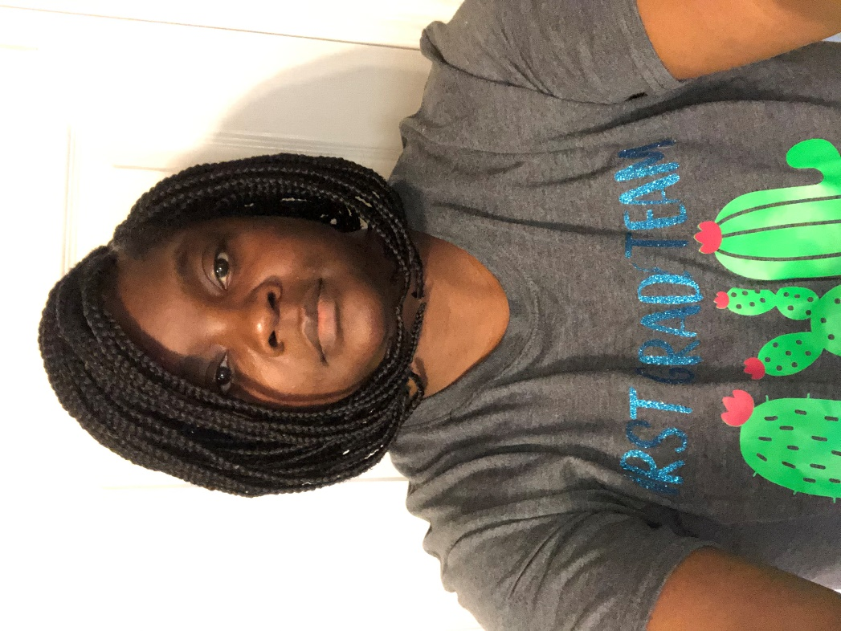 Welcome to 1st Grade!  Hello! My name is Melissa McKenzie and I am so thrilled to have you in my class this year.  We are going to learn so many new and exciting things.  I cannot wait to meet each and everyone of you.  See you soon!  Ms. McKenzie  Supply List  - 1 pencil pouch (no plastic pencil boxes)  - 2 composition notebooks (not spiral)  - 2 plastic/3 prong poly folders with pockets (, 1 blue, 1 yellow)  - 1pair of blunt-tipped scissors  - 2 boxes 24 count crayons (no smaller or larger/ Crayola preferred)  - 1 box of colored pencils  - 1 pair of headphones (no earbuds)  - 24 #2 pencils (no mechanical, Ticonderoga is BEST)  - 4- 8 glue sticks  - 2 packs wide-ruled paper  - 2 pink pearl erasers  Donations appreciated for the following (optional):  *Copy Paper * Hand Sanitizer *Dry Erase Markers *Kleenex * Disinfectant Wipes  Teacher Contact Info  Email: mckenme@boe.richmond.k12.ga.us  Phone number: 706-796-4944  ClassDojo | Syllabus  What will students learn in the class?  Language Arts: Phonics, Compare/Contrast characters, Story elements, Main Idea, Comparing Texts  Math: Number Sense, Addition/Subtraction within 100, Word Problems, Comparing 2 digit numbers, Time, Comparing Objects, Compose/Decompose 2d and 3d shapes  Science : Weather/Seasons, Living Things, Light/Sound, Magnets, Matter  Social Studies: Location, Historic Figures, Economics, Character Traits, Landforms  Submitting Assignments:  Student classwork will be collected after each assignment. Homework will be checked every Friday.  Grading Policy)  All Subjects are graded on a 1-4 Rubric Scale:  ND- Not Demonstrated  NA- Not available  1-Developing  2-Approaching  3- Mastered  4- Exceed  Grading System/Assignment Policy: Students will receive a variety of assignments designed to enhance their learning. If a student is absent, the student is responsible for the missed assignment. Students who have an excused absence will be allowed five days to turn in the missed assignment. No work will be accepted after five days.  Classroom Procedures & Expectations  - Always Try YOUR BEST!!! I will not settle for anything but your best!!  - Have the “I can do it” attitude! Stick To It and Don’t Give Up!  - Remain SEATED and PREPARED at all times.  - Bring ALL materials to class DAILY.  - Every student is responsible for helping to maintain a clean, safe learning environment. Your area must remain CLEAN at all times. The floor should be clear of trash, paper, and personal belongings.  - Adhere to all policies, rules, and regulations outlined in the student handbook, and Richmond Hill K-8 Norms.  - Listen to the teacher at all times

